2025-2026
STUDENT Registration Form
Holy Cross Parish CCD

Please complete front and back.
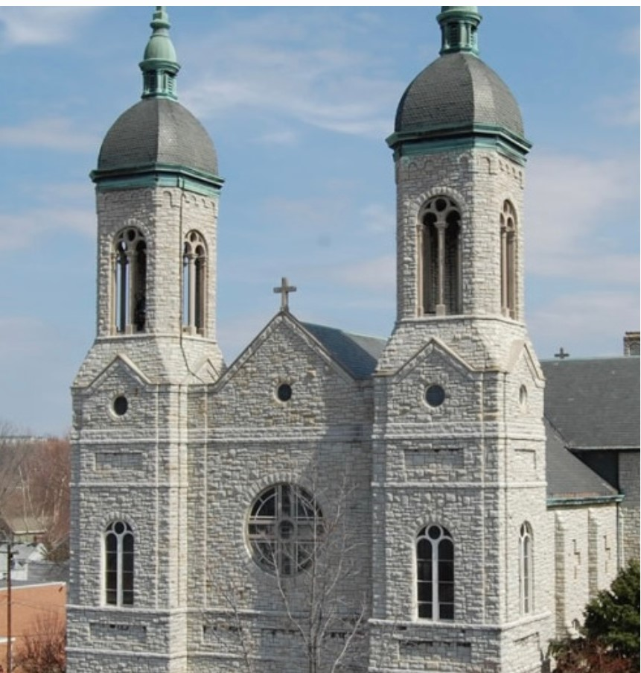
Parish ID #:

Family Name |  | Address |  | City, State |  |  | Zip |  | Home Phone Number
Student Last Name | Student First Name |  | Student’s Date of Birth |  | Student’s Place of Birth | Male/Female |  | Grade Entering* |  | School Currently Attending
Student Date of Baptism | Church Name where Baptized | Church Address where Baptized include City, State, Zip Code | Student lives with | Any notes regarding custody of student/custodial parent**
*1st grade registration forms must be accompanied by Baptism Certificate.
**Please attach any information regarding custody/custodial parent/guardian
Mother’s Name | Mother’s Maiden Name | Marital Status | Home Address (if different than student’s address) | Phone Numbers | Email Address
Home:____________________
Work:_____________________
Cell:_______________________
Father’s Name | Marital Status | Home Address (if different than student’s address) |  | Phone Numbers | Email Address
Home:_________________________
Work:_________________________
Cell:___________________________
Are there any health conditions, allergies?
Are there any behavioral or educational traits (ADHD, ADD, autism, etc.) or other information pertaining to your child which would be helpful for his/her teacher?
Any other comments or information pertaining to you child which would be helpful for the teacher?

Student’s Past Religious Education | K 1 2 3 4 5 6 7  (please circle grade completed) | Parish Name | Parish City, State

EMERGENCY CONTACTS (Please print clearly)
1ST Emergency Contact:
Name ________________________________________ Contact Number________________________________________

2nd Emergency Contact if unable to reach 1st Emergency Contact listed:
Name _________________________________________ Contact Number________________________________________

Parent Signature: _________________________________________ Date:______________________

.

RELEASES
Child(ren)'s Names: ________________________________________ ________________________________________ ________________________________________
I am a parent or guardian of the above listed child(ren) and do hereby grant permission to use my child(ren's) picture('s), video, image, and any artwork created during the Religious Education program on the church's website, video, publications, diocesan newspaper, and any of the church's publicity information, newsletters, and bulletins.
Parent Signature: _________________________________________ Date:______________________

For OFFICE USE ONLY
Date Rec'd_______________
Bap. Cert. Rec'd Y N n/a Verified_______ Pastor Letter: Y N
Parish ID #:______________________ Entered on PDS__________________

